Summer 2021 Volunteer Opportunities



St. Petersburg Athletic League

Heather Robb

(206) 356-6447



Meals on Wheels

**September 12, 2020 - A program that provides food to children and families in Pinellas County needs volunteers. Meals On Wheels for Kids relies on 125 volunteers each week to help deliver frozen prepared meals, fresh produce and shelf stable food to children and families who have opted to attend school remotely. Volunteer drivers are needed to on Mondays and Wednesdays out of Daystar Life Center in St. Petersburg, Catherine Hickman Theater  in Gulfport, and RCS Pinellas Food Bank  in Clearwater. Routes take between 60 to 90 minutes to complete. Volunteers can also sign up to help pack boxes of shelf stable food on Tuesday and Saturday mornings. Click**[**here**](https://networktoendhunger.org/mow4kids/)**for more information and to sign up. Meals on Wheels for Kids was launched by the Tampa Bay Network to End Hunger in response to Covid-19 school closures. The network also is accepting donations at**[**www.networktoendhunger.org**](http://www.networktoendhunger.org/)**to help support the MOW4Kids program**

[**https://networktoendhunger.org/mow4kids-organization-application/**](https://networktoendhunger.org/mow4kids-organization-application/)

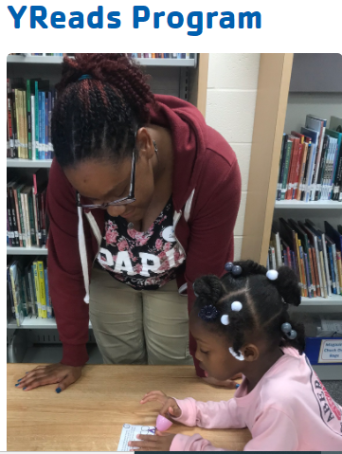

As of 2019, 44% of third grade students in Pinellas County are reading below grade level according to the Florida State Assessment (FSA). Unfortunately, students struggling to read in third grade rarely catch up – one in six students who are not proficient by that point fail to graduate high school on time, a rate four times higher than stronger readers.

YReads provides kindergarten through eighth grade students with the intensive reading instruction they need to succeed. Students are referred by teachers to work with YMCA staff and mentors in small groups during two one-hour individualized sessions per week.

We continuously measure reading skills using both i-Ready Diagnostic tests and informal assessments to provide targeted instruction and track the results of the program. Overall, 98% of students in the program see quantifiable progress in their reading skills and progress to the next grade level!

Data based on Florida Standards Assessments from the Florida Department of Education ([*Source*](http://www.fldoe.org/accountability/assessments/k-12-student-assessment/results/2019.stml))

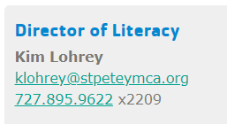

Cell # (860) 778-7655



Need Volunteer or Community Service Hours  
for High School or Bright Futures?

**Check out J.A.G Virtual – Junior Ambassadors of Goodwill!**  
**Currently offered to high school students in ten Gulf Coast counties.**  
**14-years-old and up**

As a Virtual Junior Ambassador of Goodwill, you’ll earn up to **25 hours** of community service.  This virtual program allows you to volunteer on your own at the direction of Goodwill Volunteer Services.  Each program activity supports a different aspect of the Goodwill-Suncoast mission to ***transform lives through lifelong learning and the power of work*.**

**Click**[**HERE**](https://issuu.com/goodwill-suncoast/docs/jag-handbook-011321_update_finsingles)**for J.A.G. Virtual Handbook**  
*(If you are unable to access the Handbook, please contact our Accessibility Coordinator.)*

**Click**[**HERE**](https://goodwill-suncoast.org/junior-ambassadors-of-goodwill-virtual-sign-up/)**to REGISTER for J.A.G. *Virtual***

**We will begin taking JAG Virtual applications again on May 1, 2021 for the July/August Session. Please return then to submit an application.**

*(Please choose the Quarter during which you would like to participate on the application)*



# Volunteer with the Tampa Bay History Center

The History Center is looking for energetic and committed volunteers to help create a great experience for visitors or provide much needed behind-the-scenes support. Volunteers learn new skills, work with motivated people who share common interests, and help visitors of all ages connect with the past. If you have an interest in history and want to share your enthusiasm and talents, we encourage you to apply to become a volunteer.

Contact:

Amanda Hoffman

(813) 675-8987